SRI MANAKULA VINAYAGAR ENGINEERING COLLEGE

(Accredited by NAAC with ‘A’ Grade, Accredited by NBA-AICTE, New Delhi & ISO 9001:2000 certified Institution)

DEPARTMENT OF COMPUTER SCIENCE AND ENGINEERING
STUDENT PROFILE
PHOTO

BATCH: 2023 – 2027
PERSONAL DETAILS

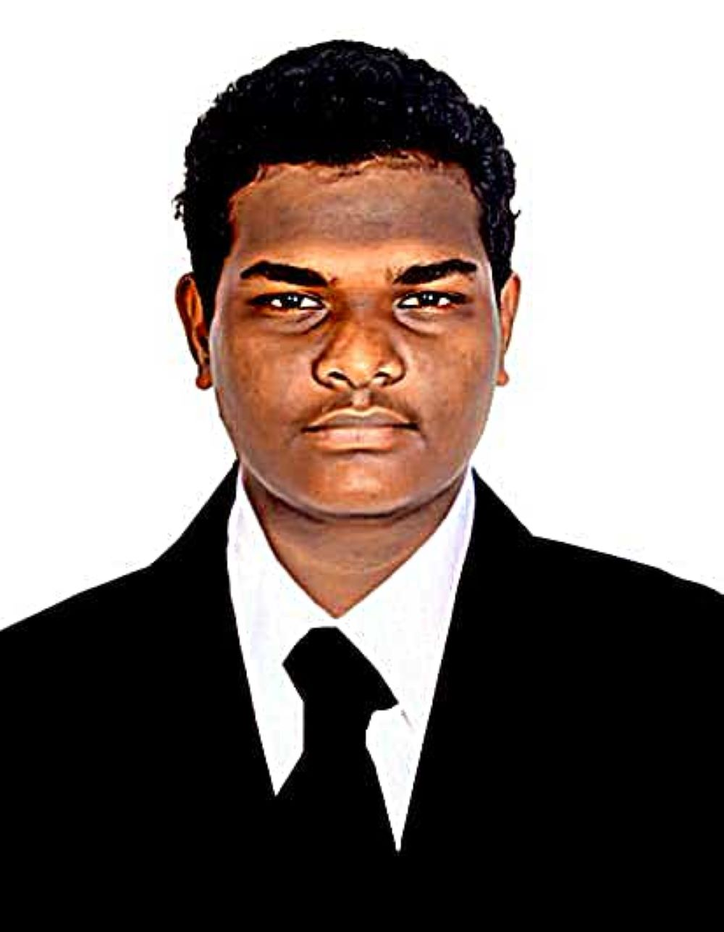
1. NAME OF THE STUDENT : | BALASUBAMANIAN S
2. REG NO. : | 23UCS022
3. ENROLL NO. : | 230980
4. DATE OF BIRTH : | 13.05.2006
5. GENDER : | MALE
6. FATHER’S NAME : | SIVAKUMAR S
7. MOTHER’S NAME : | THARA S
8. FATHER’S OCCUPATION : | ELECTRICIAN
9. MOTHER’S OCCUPATION : | HOME MAKER
10. CONTACT ADDRESS : | NEW NO. 30, 1ST CROSS STREET THIRU VI KA NAGAR MUDALIARPET,PUDUCHERRY-605004
11. PHONE NUMBER  FATHER :  MOTHER :  STUDENT :  LAND LINE : | 9159819946 WhatsApp No: 8015216708  9487982287  8015216708
12. ADMISSION : | CENTAC/MANAGEMENT
13. RELIGION : | HINDU
14. COMMUNITY & CASTE : | MBC & VANNIAKULA KSHATRIYA
15. STATE & NATIONALITY : | PUDUCHERRY & INDIAN
16. EMAIL ID (STUDENT) : | btechcse230980@smvec.ac.in
17. BLOOD GROUP : | B+

EDUCATIONAL QUALIFICATION

S. No | Qualification | Name of the School / Institution Studied | Board Studied | Year of completion | Marks obtained | % obtained
1. | X STD | PETIT SEMINAIRE HR.  SECONDARY SCHOOL | STATE BOARD | 2020-2021 | ALL PASS | ALL PASS
2. | XII STD | PETIT SEMINAIRE HR.  SECONDARY SCHOOL | STATE BOARD | 2022-2023 | 543/600 | 90.5
3. | Diploma (If any)

ACADEMIC PERFORMANCE

SECTION:
GRADE | I SEM | II SEM | III SEM | IV SEM | V SEM | VI SEM | VII SEM | VIII SEM
GPA | 8.57
CGPA | 8.57
Arrears (If any)
Note: Those who have arrear, the students should write the Arrear Subjects and CGPA in pencil.

STUDENT’S ACHIEVEMENTS

EXTRA / CO CURRICULAR ACTIVITIES

SIGNATURE OF THE STUDENT

